Segun Afolabi 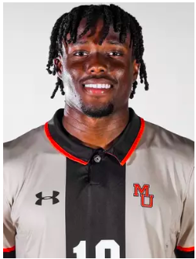

**Personal Info**:

DOB: 08/07/2002 Height: 6’1 Weight:190lbs

Place of Birth: Kennesaw, GA Citizenship: USA, Nigeria

**Highlight Tape**: <https://youtu.be/8sEy9twoX80?si=u64Kma4_qcg6CzHy>

**Contact Info**:

Home Address: 2804 Brass Way, Austell GA 30106

E-mail Address: segungab2002@gmail.com

Phone Number: 404-966-0519 (Best place to contact)

**School**: Current School: Mercer University

Graduation: Graduated

Soccer History

Clubs:

Southern Soccer Academy Kings (USL 2), 2022-23, Center Forward

Coaches: Jack Coulton, Gareth Baker

Stats : 15 Games Played

9 Goals 4 assists

University of South Florida (NCAA Division 1) Forward/Winger 2020-2023

Coach : Bob Buterhorn

Mercer University (NCAA Division 1) Forward/Winger 2024

Coach: Brad Ruzzo

Stats : 16 Games Played

4 Goals 4 Assists

Strengths: A strong, physical, natural goal scorer but can also be used as a hold-up striker and help maintain possession and find overlapping Wingers and score goals when inside 25 yards, I can also slash and stretch the field. Making runs in behind Defenders etc.

References:

Armante Marshall (USF)

+1 (850) 284-6809

Todd Gispert (Academy)

+1 (770) 656-6657

Bob Butehorn (USF)

+1 (239) 707-2948

Brad Ruzzo (Mercer)

+1 (478) 550-7063